**Invoice(s) Items to fix:**

An email is set to kick out every 5 minutes when a transaction has no invoice attached to it and will continue to do so until the invoice(s) is/are fixed. The email consists of the RT and Trans ID/Receipt # which can be used to search later. Follow the following procedure to fix the invoice(s).

1. Get the RT and Trans ID (Receipt #) from the email.

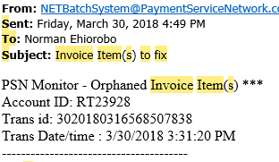

1. Search the RT using Accounts Tracker🡺Account Management DashBoard.

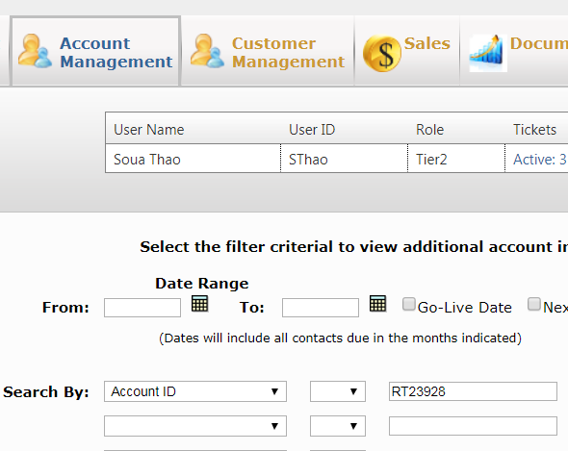

1. Once inside the AMC --> go to Payment Tracker --> View Real-time Payment Trans.
2. Search for that trans ID (Receipt #) by clicking List.

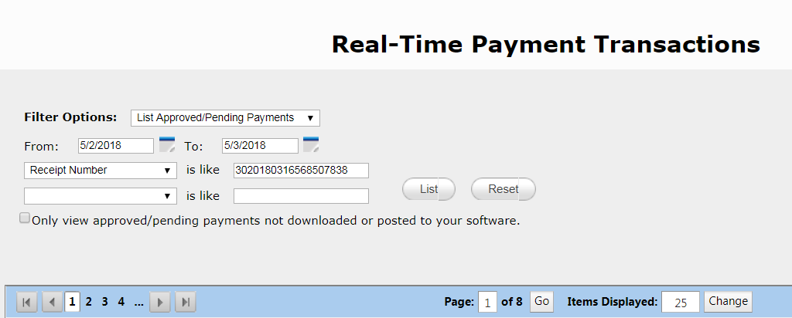

1. When a transaction has no invoice, the Invoices column is blank.

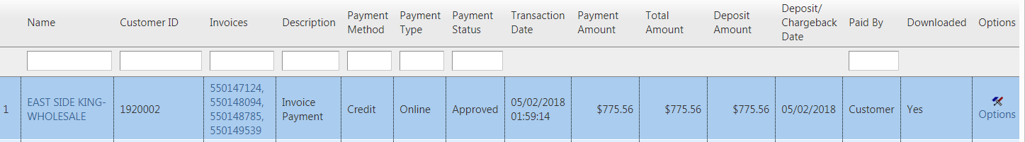

1. Click Option (far right), select Add Invoice, then apply payment amount to the invoice(s).

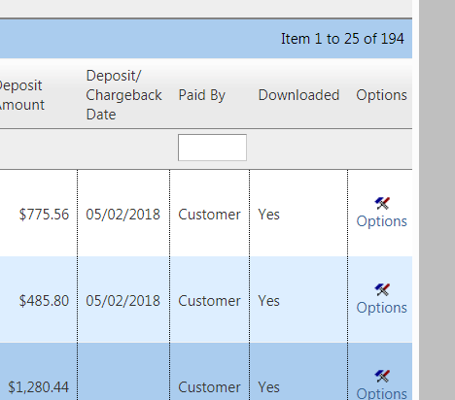

1. Once things are done correctly, you should see the following.

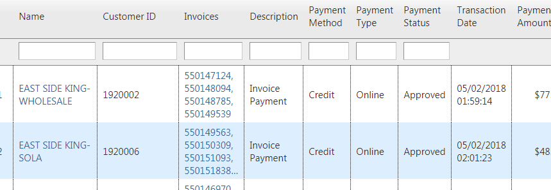

Caution:

When there are more than one invoices, split the amount accordingly and make sure the total adds up after you’re finished.